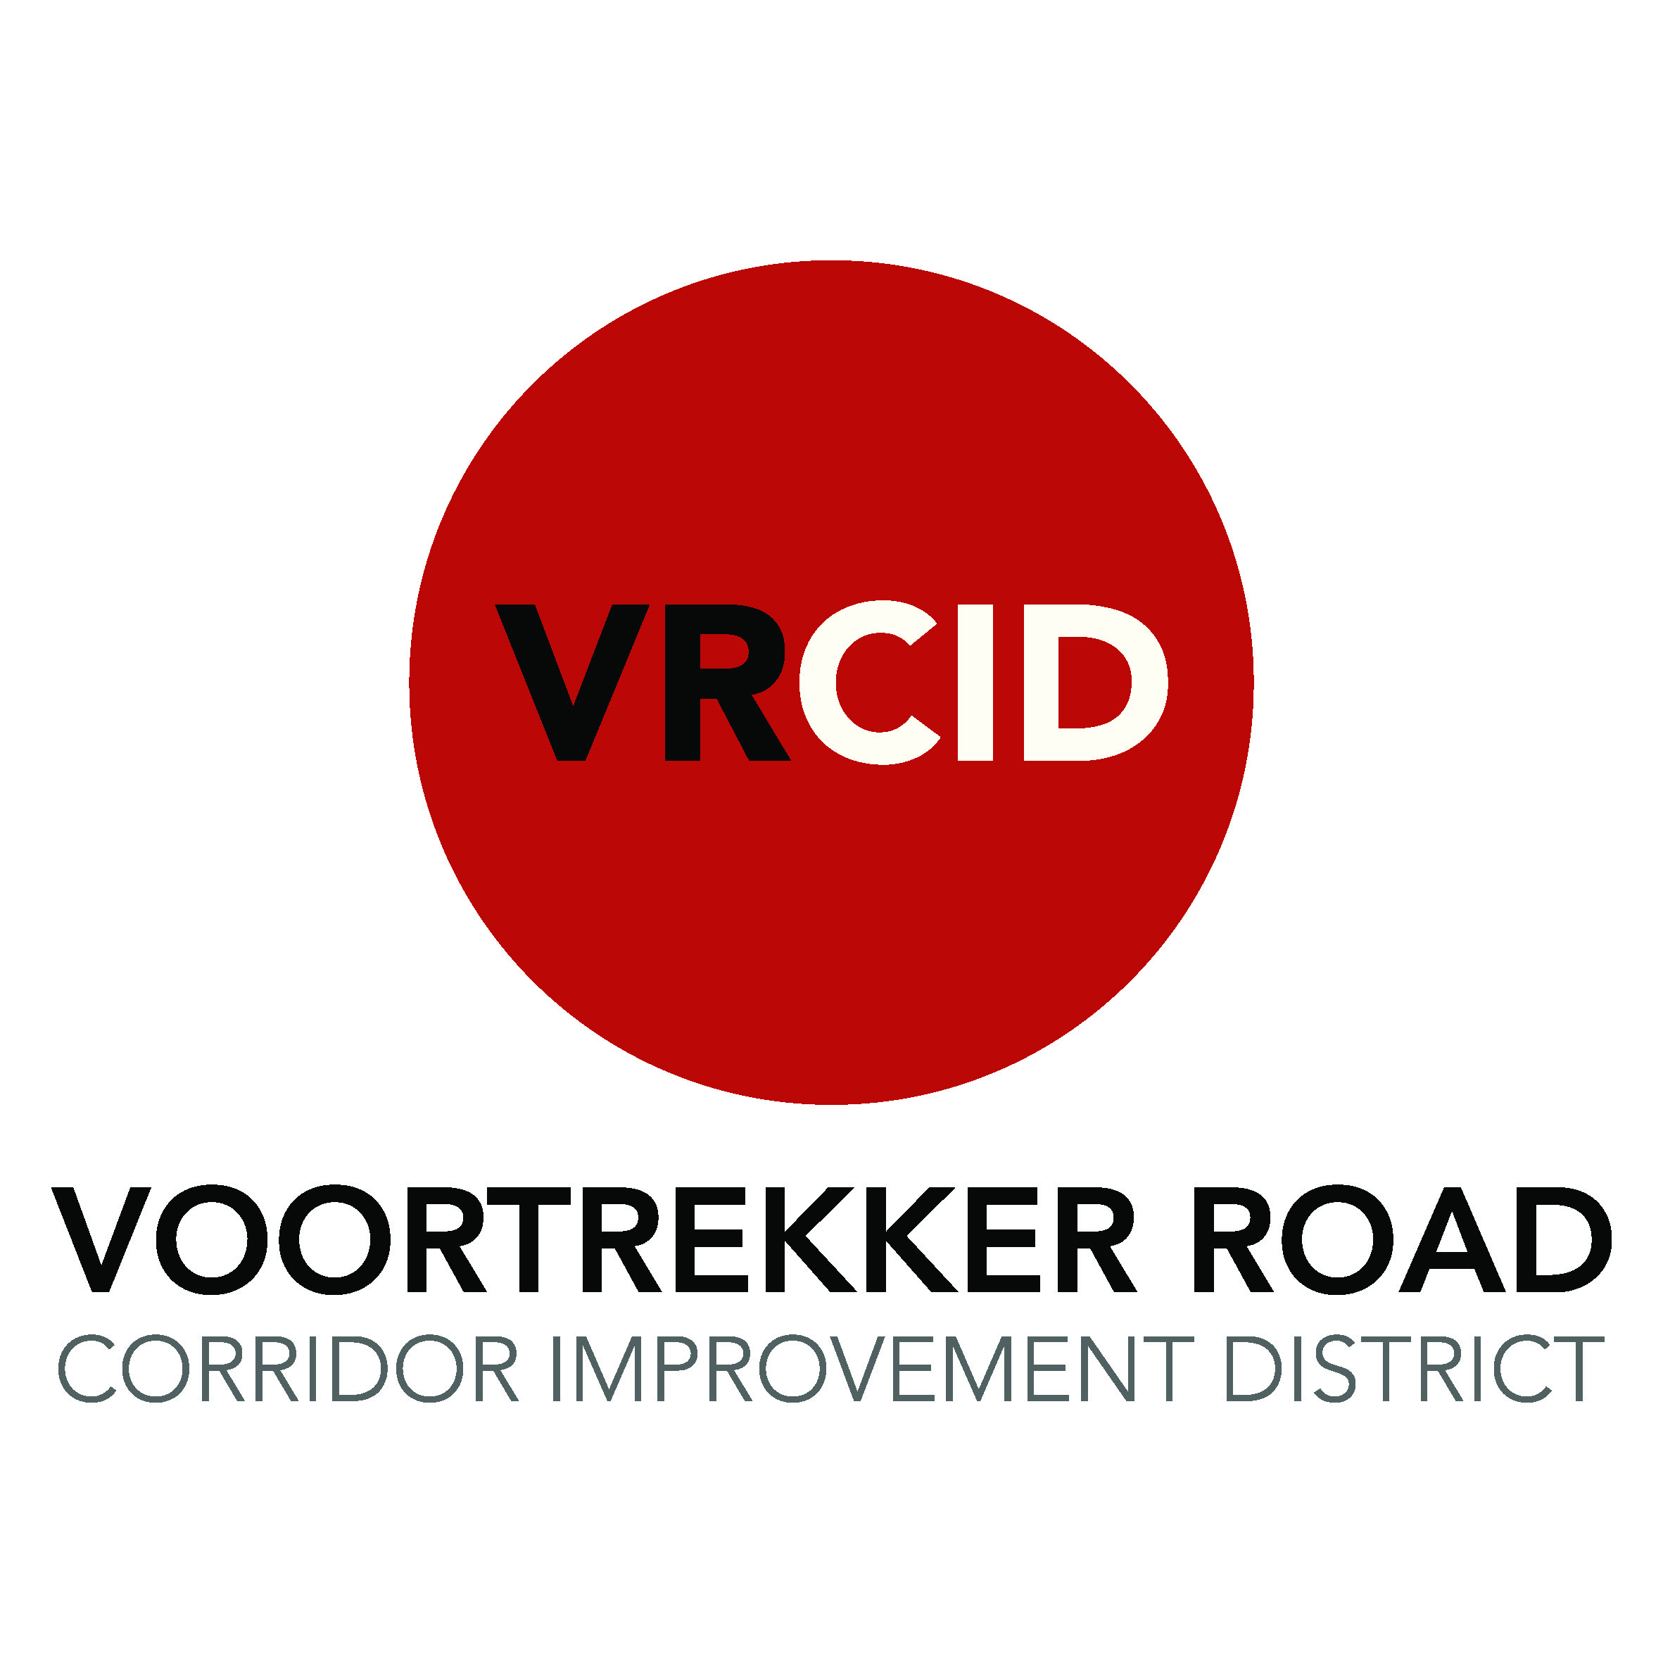

REGISTRATION FOR MEMBERSHIP OF THE VOORTREKKER ROAD CORRIDOR IMPROVEMENT DISTRICT NPC

Property owners are eligible for membership of the VRCID. Supply the VRCID office with the following information in order for a Membership Certificate to be issued. This is a requirement of the REGISTRAR OF COMPANIES:

Representative’s Details:

Full Name & Surname: _________________________________________________________________

Identity Number: _____________________________________________________________________

Residential Address: ___________________________________________________________________

___________________________________________________________________

____________________

E-Mail: _____________________________________________________________________

Company / Property Being Represented details:

Company Name: __________________________ Registered Owner: _________________________

Physical Address: Postal Address:

________________________________________ __________________________________________

_________________ __________________

Telephone: _______________________________ Cell Phone: ________________________________

_______________________________________________________________________________

Erf Number(s) of Property(ies) Represented

I hereby confirm that I am the Authorised Representative or am elected by means of a resolution (If applicable) from the Landowner of the above mentioned erwen.

Thus done and signed at ___________________________ on this ________

day of _____________________________ 2021

__________________________________________________

Signature Company Stamp

For office use: LIS Key: _____________ Valued with: _____________

Date Received at VRCID: ________________ PU: __________

Voortrekker Road Corridor Improvement District NPC; Registration Number 1996/004458/08
3A Bellpark Building, Cnr Durban and De Lange Roads, Bellville, 7530; P.O. Box 902, Bellville, 7535; VAT No: 4790261210
Telephone : 021 823 6713; E-Mail: leonie.vandermerwe@vrcid.co.za; website : www.vrcid.co.za

